Zen Garden Theme: Swiss Modern Bold

By Jessica Evans and Sarah Barrett

Fonts: Montserrat & Noto Serif SC

@import url('https://fonts.googleapis.com/css?family=**Montserrat:800|Noto+Serif+SC**');

Color Palette:

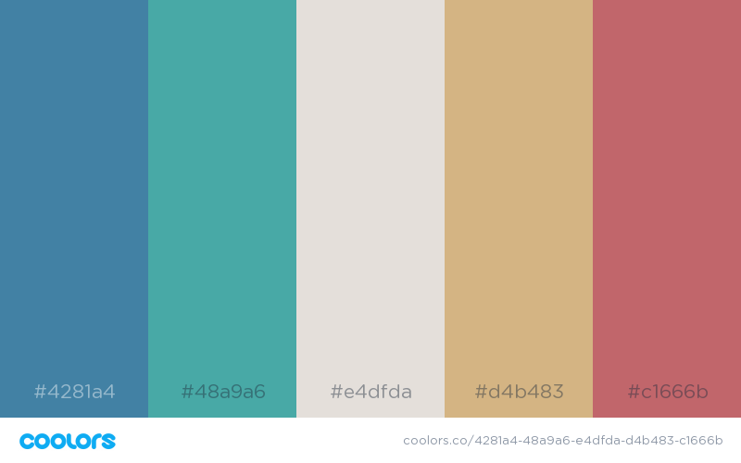

CodePen: <https://codepen.io/Jess2397/pen/XOaNdq?editors=1100>

